1. **Domain Analysis**

Domain model:

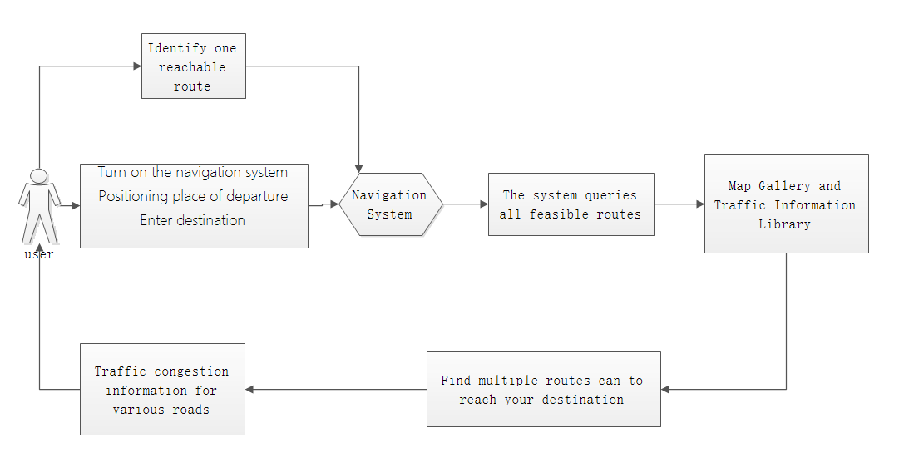

1. **Domain Model**

The establishment of the domain first analyzes the sequence of operations that the user appears in the operation navigation software, analyzes the associations that may occur through various operations, and finally derives the association between the user and the navigation system.In the model diagram of the domain, the user first opens the navigation system and enters the destination. The navigation system analyzes the location of the user and the location of the destination, then enters the map library in the navigation system for analysis to obtain multiple routes that can be reached. At the same time, the information of multiple lines is fed back to the user. The user confirms a road through the software, and the software finds the relevant road condition information in the road condition information base by the road selected by the user, and finally returns the road condition information to the user.

**b.System Operation Contracts**

Through the analysis of the above information, the key information is finally obtained: user, Navigation System, Map Gallery and Traffic Information Library.

However, these key information needs to be related, so the correlations are obtained by analysis: Turn on the navigation system, Positioning place of departure, Enter destination, The system queries all feasible routes, Find multiple routes can reach reach your destination, Traffic Congestion information for various roads, Identify one reachable route.